AGILITY
FUN MATCH
4 Runs Starters/Advanced level
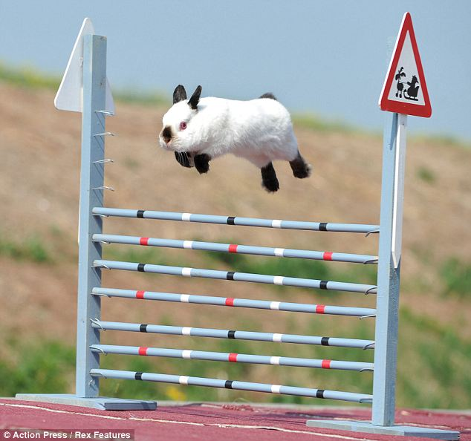

Sunday May 13, 2018 starting 8:30 a.m.
Dick Hart Memorial Park
Kamloops (Heffley) B.C.
Outdoor on grass

YVONNE BABIJ and MARY ZACHARATOS
May 12 and 13, 2018
Hosted by 5 Star Dog Training
ENTRY FORM
Name: ____________________________________________________________
Phone :_______________________________ cell:_________________________
Address:_______________________________City: ________________________ Prov:_______________ Postal Code:____________________________________
Email:_____________________________________________________________
Dog’s Name:_______________ sex: _____age: _____ breed:_________________

tic
 | Sunday Funs Match $10 per run  Gambler 1 _____ Gambler 2_______  Jumpers 1 ______ jumpers 2 _______ | $10.00 plus tax | $10.50
 | Pre- enter 4 or more $9.00 each plus tax. This is per handler, so if you have 2 dogs and enter 4 or more runs, then $9.00 per run. Same day (Sunday) add ons accepted at $10/run.  Gambler 1 _____ Gambler 2_______  Jumpers 1 _____ Jumpers 2 _______ | $9.00 plus tax | $9.45
 | TOTAL ENTRY FEE INCLUDED

Cheques payable to: 5 STAR DOG TRAINING
Mail entry form/cheque to: 5 Star Dog Training, 229 Chetwynd Drive, Kamloops, B.C. V2H 1L7
Or email entry form to zacharatosmary@gmail.com and pay by e-transfer to zacharatosmary@gmail.com
THE WAIVER (NEXT PAGE) MUST ACCOMPANY THIS ENTRY FORM.

TOYS AND FOOD OKAY! If using food, be careful to not drop any in the grass – no flaky treats.

5 Star Dog Training
www.fivestardogs.ca
Handler Information:
Name:_______________________ phone:_____________ email:_______________________
Address: ________________________ City:_______________ Postal Code: _______________

IF BRINGING A DOG:
Dog Information:
Dog’s Name: ___________________ Birth Date: _____________ Breed:_________________

By signing this document you will waive certain legal rights, including the right to sue.
Please read carefully
Re: Dog Training Events to be held through 5 Star Dog Training
To: 5 Star Dog Training and its Executive, Directors and Members;
AND TO: The Instructor(s) all of whom are hereinafter collectively referred to as “the Releasees”

I am aware that the event has, in addition to the usual dangers and risks inherent in the sport of dog training, such as being bitten, further dangers and risks including but not limited to slipping, collision with other participants or instructors or spectators, and I freely accept and fully assume all such dangers and risks and the possibility of injury, death or property damage to me, my next of kin or my dog and the losses, costs and damages which may result there from.
That I freely accept and fully assume all such dangers and risks associated with being a participant of dog training events being held by 5 Star Dog Training, including but not limited to the possibility of injury, death or property damage to me, my next of kin or my dog and any losses, costs and damages which may result there from.

In consideration of the Releasees accepting my application for Classes: I HEREBY AGREE AS FOLLOWS:
- TO WAIVE ANY AND ALL CLAIMS that I may have against the Releasees;
- TO RELEASE THE RELEASEES FROM ANY AND ALL LIABILITY for any loss, damage, injury or expense that I may suffer or that my dog may suffer or that my next of kin may suffer as a result of my participation in the dog training event due to any cause whatsoever, INCLUDING ANY NEGLIGENCE ON THE PART OF THE RELEASEES;
- TO HOLD HARMLESS AND INDEMNIFY THE RELEASEES from any and all liability for any property damage, personal injury or death to any third party, or their dog, resulting from my participation in the dog training event;
- THAT this Release of Liability shall be effective and binding upon my heirs, next of Kin, executors and administrators and assigns in the event of my death.
I am of the full age of nineteen (19) years and I HAVE THE LEGAL AUTHORITY to sign on behalf of any next of kin which may accompany me to the Classes and I HAVE READ AND UNDERSTOOD THIS RELEASE OF LIABILITY PRIOR TO SIGNING IT, and I am aware that by signing this Release of Liability I am waiving certain legal rights which I or my heirs, next of kin, executors, administrators and assigns may have against the Releasees.

Dated the _____ day of ________________ 20 ______
___________________________ ________________________
Signature of Participant Parent or Guardian
Must be signed by the participant or parent or guardian before the participant will be permitted to participate in dog training events.

