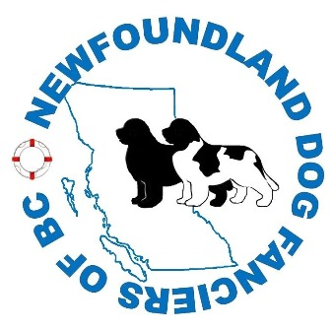 

**NEWFOUNDLAND DOG FANCIERS OF BC**

**All-Breed HEART CLINIC**

Saturday July 21, 2018

In conjunction with the NDFBC

“Kitchen Party”

Mostabear Newfoundlands

10597 Hwy 97D, between Kamloops and Merritt at Exit 336 off Coq. Hwy

5kms toward Logan Lake, BC

**SAS Heart Screening and Doppler Echocardiogram performed by**

**Board Certified Cardiologist Dr. Kimberley C. E. Hawkes**

**Guardian Veterinary Center, 5620 99th St. NW Edmonton AB, T6E 1V2**

Fill out and mail/email the clinic form with your **cheque payable to NDFBC**. We will also accept E-transfers but attendee must pay fees by deadline. Late entries must pay by cash.

Send to NDFBC Clinic c/o Christine Grouhel, Box 557, Logan Lake, BC, V0K 1W0

or E-transfer to [mostabearnewfoundlands@gmail.com](mailto:mostabearnewfoundlands@gmail.com)

Please put *NDFBC Heart Clinic* in the subject line for any correspondence.

OFA Cardiac Applications available at: [http://www.offa.org/pdf/cardapp bw.pdf](http://www.offa.org/pdf/cardapp%20bw.pdf)

Please print / complete the top half of the application(s) and send to the address above along with the clinic form below.

|  |  |  |
| --- | --- | --- |
| **CLINIC FEE** | NDFBC Member | **Non** NDFBC Member |
| **Auscultation** ONLY | $60 | $65 |
| Doppler **Echo**cardiogram (auscultation included) | $225 | $250 |
| **Vet Referred** Consult / Echo (auscultation included) | $450 | $450 |

Form(s) must be printed clearly and submitted by July 13, 2018. Complete one form for each dog. Late entries will be subject to a $5 late administration fee.

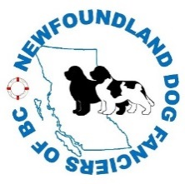

**NDFBC Heart Clinic Registration Form**

|  |  |
| --- | --- |
| Dog’s Registered Name |  |
| Registration number |  |
| Circle one | CKC / AKC |
| Sex | Male / Female |
| Breed |  |
| Tattoo / Microchip # |  |
| Sire Registration # |  |
| Dam Registration # |  |
| Date of Birth  (please write in full ie: July 18, 2018) |  |
| Owner(s) Name |  |
| Full Address |  |
| Phone number |  |
| Email Address |  |
| Dog Call Name |  |
| Service Required  (pls circle) | Auscultation Echo Vet Referred Consult/Echo |
| Pls advise species if NOT a dog  (ie/ cat) |  |

You will be called or emailed before the clinic with your appointment times once all registrations

are completed