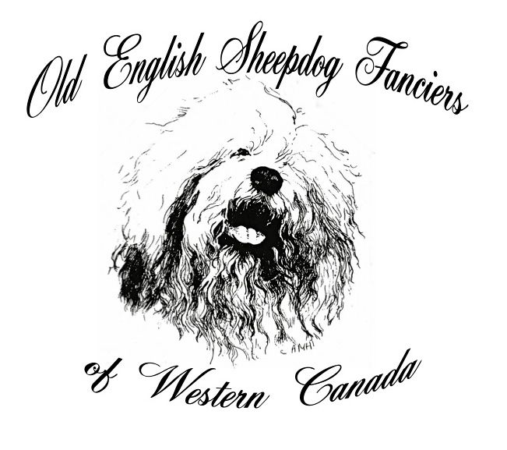 | All-Breed CKC Approved  Rally Obedience Sanction Match  Judge: Ayoka Bubar  6:30 p.m., Friday, December 1, 2023  Indoors at the  Wascana Dog Obedience Club  513 E Ross Ave., Regina, SK  Limited entry of 150 minutes

Match Secretary Match Chair/Superintendent
Lavella Shaw Saskatoon, SK Val Bandas, Craven, SK
(306) 270-3895
l.shaw@sasktel.net

ENTRY INFORMATION
Closing Wednesday, November 29, 2023, 6:00 PM CST or when limit is reached.
Day of Entries will not be accepted.

The following classes will be offered:
Novice, Intermediate, Advanced, Excellent and Master

Ring size: 40’ x 50’

Entry fees – $10.00 per class

Email entries to the Match Secretary at l.shaw@sasktel.net

Pay entry fees by etranster to l.shaw@sasktel.net
Each dog must be entered on a separate entry form
Entries are not considered complete until payment has been received in full.

This event will be held under the rules of the Canadian Kennel Club (CKC). As per CKC rules dogs entered in an obedience sanction match must be six (6) months of age or older and must be eligible for CKC Registration. Any qualifying scores earned in a sanction match do not count toward official tiles

OFFICIAL OBEDIENCE ENTRY FORM

OLD ENGLISH SHEEPDOG FANCIERS OF WESTERN CANADA
SANCTION MATCH
Friday, December 1, 2023

I ENCLOSE $_________ FOR ENTRY FEES $________
Please type or print clearly
Breed | Sex
Enter in the following Class:
[ ] Novice A | [ ] Excellent A |  | JUMP:
[ ] Novice B  [ ] Intermediate | [ ] Excellent B  [ ] Master |  | HT ________
[ ] Advanced A |  |  | WD ________
[ ] Advanced B
Reg'd Name of Dog: Call Name:
Check one - and - Enter Number here | Date of Birth | D M Y
CKC Reg. No. _________________________
CKC ERN No _________________________
CKC Misc.Cert. No. _________________________
TCN Reg No. __________________________
CKC CCN __________________________ Place of Birth [ ] Canada [ ] Elsewhere
CKC PEN __________________________ _______________________________________________________________________
Breeder(s)
Sire
Dam
Reg’d Owner(s)
Owner’s Address
City |Prov. |Postal Code
Name of Owner’s Agent (if any) at the show:
Agent’s Address
City |Prov. |Postal Code

I CERTIFY that I am the registered owner(s) of the dog or that I am the authorized agent of the owner(s) whose name(s) I have entered above and accept full responsibility for all statements made in this entry. In consideration of the acceptance of this entry, I(we) agree to be bound by the rules and regulations of the Canadian Kennel Club and by any additional rules and regulations appearing in the premium list.

___________________________________________________________________________ (______)_______________________
SIGNATURE OF OWNER/AGENT TELEPHONE NUMBER

E-MAIL ___________________________________________________________________________
PLEASE PRINT CLEARLY

