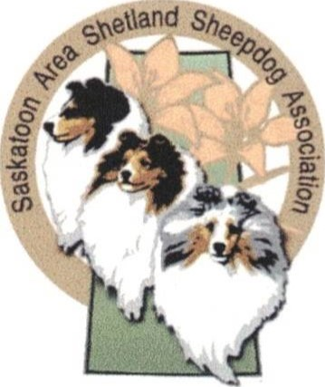

Saskatoon and Area Shetland Sheepdog Association

Herding Instinct Testing at Sheep Thrills Farm, Grandora, SK

Date : Sunday May 25, 2025

Cost: $50 per dog - To ensure a spot, please send in this form, and fees as soon as possible. Testing is limited to 25 dogs, and starts at Pre-registered dogs will take priority over those not preregistered, but we will try to accommodate everyone.

There is a STRICT stoop N scoop policy. ALL dogs must be on leash, crated or x-penned at all times when not being tested. You need to bring with you, a flat buckle collar, a minimum 6' leash (no flexies!), your own water/refreshments, lawnchair and a camera!

How to find Sheep Thrills Farm: You can find Sheep Thrills Farm on Google Maps!

Located about 15 minutes from Saskatoon. To get there, head west on 22nd Street on Hwy 14. At the Sandyridge gas station, turn left (south) onto Young Road. Go 1 mile to the stop sign, then turn right (west) onto the paved road. Go about a mile, they are the last place on the right hand side just before the train tracks. There is a metal gate across the drive with dogs on it, please close it behind you if you opened it.

For more information, please contact:

Sandra Wiebe 306 229 7179 or sassa21sk@yahoo.com

Please complete the registration and waiver form along with your etransfer to sassa21sk@yahoo.com

Saskatoon & Area Shetland Sheepdog Association

Herding Instinct Testing Registration & Waiver

Owner/Agent Name:

Address:

Phone:Email:



Dog(s) Name: Certificates will be issued to passing dogs. Please put the dogs name as you would like it to appear..

Payment Enclosed:($50.00 per dog )

I hereby release from responsibility the SASSA, facility owners, herding committee, instructors, testers and exhibitors from any costs incurred as a result of any damage to my property, my dog(s), or me. I understand that I am responsible for any costs incurred as a result of any damages caused by myself or my dog(s) to facilities, persons or animals. My payment acknowledges that I have read this form and that I am responsible for any costs incurred as a result of damages caused by myself or my dog(s) to the facilities, animals and/or persons. Replacement cost of sheep is $350.00, replacement cost of ducks is $100.00.

I understand that there will be no refunds of registration fees should I am unable to attend.

Signature Date